**SOLENT UNIVERSITY**

School of Media Arts and Technology

**BSc (Hons) Software Engineering (BCC608)**

Academic Year 2022-2023

Student ID: 16119533

Date of Submission: 19th December 2022

# Abstract

In order to compete in the market and increase tourism, tourism organizations have expanded the services they offer by offering additional tour packages and plans. In such cases, keeping an excellent website is a crucial necessity. Providing services and amenities to visitors to the island is more beneficial, and they should receive travel packages and itineraries that meet their needs.

The main contents of the page will scroll along with a few key features and actions carried out by the web-based application for the employees and employees who have an impact on local and international clients and the tourism firm. managing travel packages. Only the needs outlined in the case study are the focus of the suggested system.

# Acknowledgement

Contents

Abstract 3

Acknowledgement 3

Abbreviations 6

Chapter 1 - Introduction 7

Scope and Purpose 7

Objectives 7

Chapter 2-Requirement Specification 8

2.1. Functional Requirements 8

2.2. Non-Functional Requirements 8

2.3. Interfaces 9

Requirement Analysis 11

2.4. Rich picture of the existing system 11

2.5. Mind map for the system 12

# Abbreviations

CRUD - create, read, update, and delete

WBS -Work Breakdown Structure

UML- Uniform Modelling Language

PaaS -Platform as a Services

ERD -Entity Relational Diagram

# Chapter 1 - Introduction

Real-time information should be extremely carefully controlled and maintained for decision-making in human normal operations since technology has advanced to the point where the entire world depends on automated systems and data. The data should be gathered, saved, processed, and made available as needed. As a result, a suggested web-based system is created for a tourism organization that meets the needs of the client.

## Scope and Purpose

When a tourism industry uses an antiquated, manual approach, it is exceedingly difficult. Negative effects on providing clients with a satisfied experience result from maintaining an obsolete and subpar management system. Therefore, in today's quick-paced world, it is essential to have an updated and sophisticated dynamic website to give visitors a way to receive the information they need before making reservations.

The project's goal is to create and provide a hosted web application with effective package services, dependable security, and an intuitive user interface to satisfy customers and stakeholders. Customers should have no trouble making reservations using a web-based application since many businesses rely on the internet for their daily operations. It is anticipated that a hosted system using Java technology will achieve the desired result in the allotted time.

## Objectives

The following are a few objectives that were able to focus on the key needs that were necessary to attain the project's final results.

* ensuring the needs of the stakeholders.
* minimizing human error

The major goal of handling information and developing web applications is to provide better booking services to local and foreign tourists. This is done in order to handle various features that are necessary in an organization in order to decrease costs and paperwork.

# Chapter 2-Requirement Specification

## 2.1. Functional Requirements

The system is set up with certain tasks that must be completed in accordance with the privileges that have been granted.

* The system must be web-based.
* There should be a customer registration page for new users and a login page that directs users to their individual dashboards, whether they are administrators or customers.
* CRUD operations are expected for hotel information
* The information about reservations should have CRUD functions.
* Should provide CRUD functions for managing feedback
* Administrators ought to have CRUD methods for package data.
* Customers ought to be able to submit inquiries.

## 2.2. Non-Functional Requirements

* A user-friendly interface is one that has been built with the user in mind.
* Efficient System with Neatness - Followed good coding practices which will be useful in the industrial level
* An effective system with high cleanliness was created by adhering to high coding standards that will be helpful at the industrial level.
* Speed- Although the system was designed to be easily accessible and use the newest technologies, its speed still depends on the consumers' network speed.
* The application was designed, launched, and fully functional on the cloud platform for free thanks to the system's hosting, which used the quickest and most effective cloud (PaaS).
* Simple to use—Maven technology is employed, and the project's dependencies are correctly setup and maintained, allowing the database H2 to operate with ease.
* More practical and dependable due to its excellent functionality.
* The usage of the confidential information is strictly kept in a secure manner since any user can obtain authorization through their identification.
* Data is rigorously safeguarded, and authentications ensure data security.

## 2.3. Interfaces

The interfaces of the following Tourist Management System are used to validate the final design.

# Requirement Analysis

Requirement analysis is a step in the requirement engineering process that involves gathering, filtering, and validating client needs. The project's objectives are achieved through analysis of the anticipated application result. It contains all of the methods and techniques that have been used during the project's development. A thorough system study may be part of this.

## 2.4. Rich picture of the existing system

The detailed graphic aids in providing succinct summaries of challenging circumstances. It facilitates a more visionary perspective of the project boundary and facilitates the comprehension of critical relationships, stakeholders, changing conditions, and key elements.

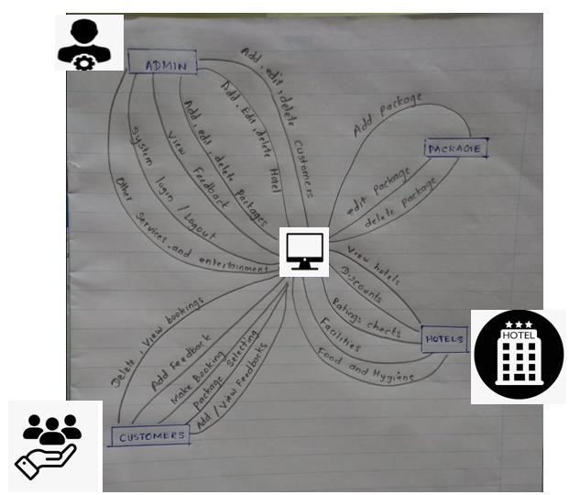

## 2.5. Mind map for the system

whereas the interconnectedness of the system is discussed using diagrams and symbols in a way that perfectly explains the deep aim, they are used to convey the entire topic at a simple context level.